**

Copyright for test papers and marking guides remains with *West Australian Test Papers.*

Test papers may only be reproduced within the purchasing school according to the advertised Conditions of Sale.

Test papers should be withdrawn after use and stored securely in the school until Friday 14th June 2019.



**MATHEMATICS**

**METHODS**

**UNIT 3**

**Semester One**

**2019**

**SOLUTIONS**

***Calculator−free Solutions***

1. (a) 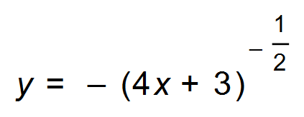

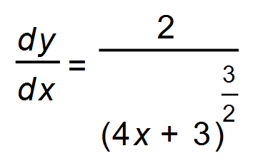 ✓

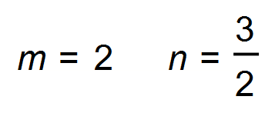 ✓

(b) 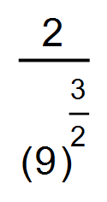

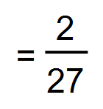 ✓ [3]

2. (a) 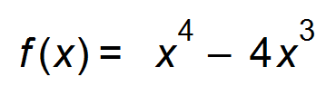

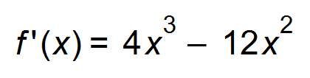

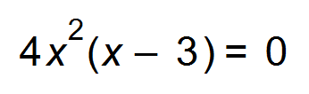 ✓

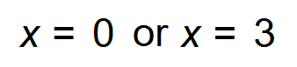 ✓

Stationary points (0, 0) and (3, 27) ✓

(b) 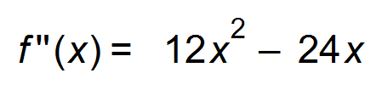 ✓

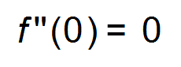∴ horizontal point of inflection occurs at (0, 0) ✓

** (3, −27) ✓✓

(c) (i) 

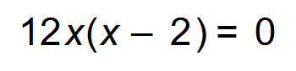

∴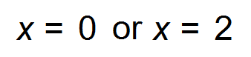 ✓

Point of oblique inflection at (2, 16) ✓

(ii) *m* = 16

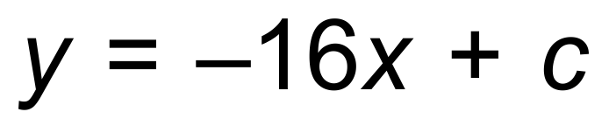 ✓

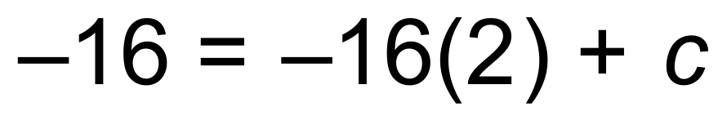

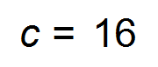

Tangent is 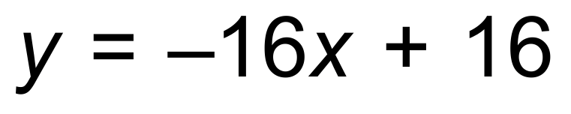 ✓ [11]

3. (a) 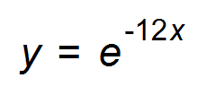

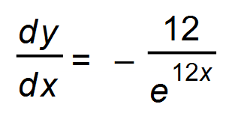 ✓✓

(b) 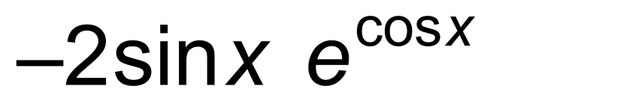 ✓✓ [4]

4. (a) The values of *f*(*x)* are all positive ✓

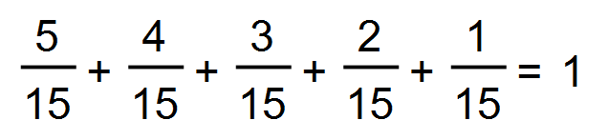 ✓

∴ Probability function

(b) 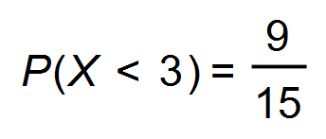 ✓

(c) 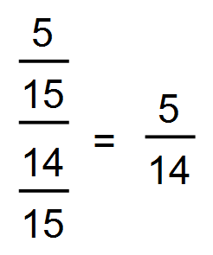 ✓✓ [5]

5. 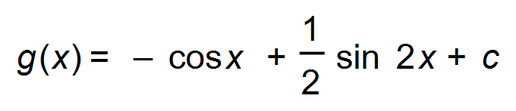 ✓

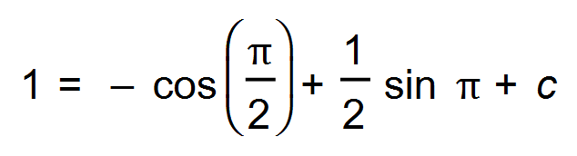 ✓

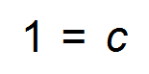

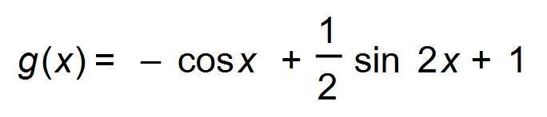 ✓ [3]

6. (a) 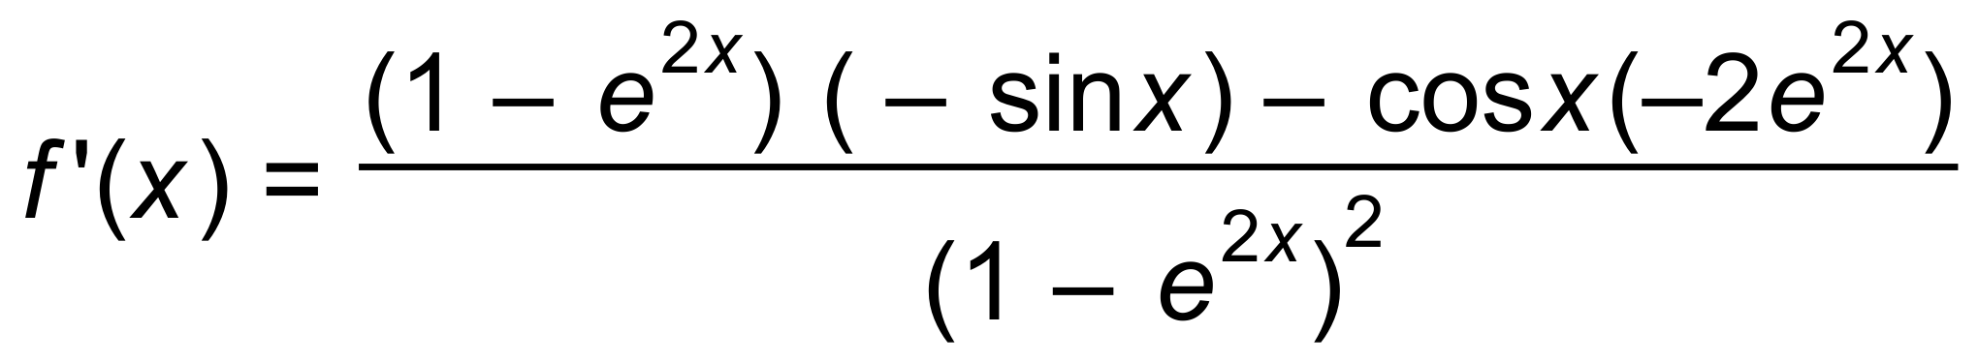 ✓✓

(b) 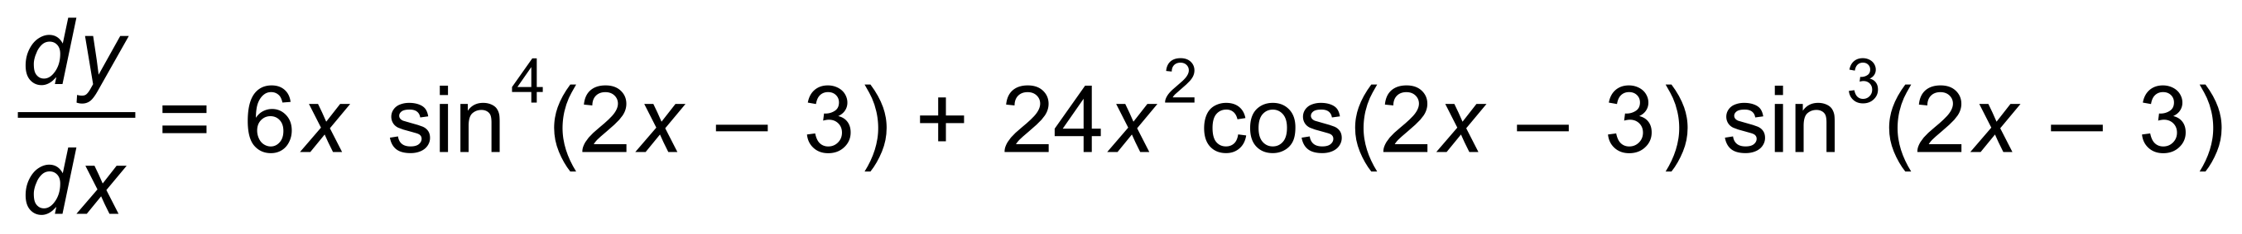 ✓✓ [4]

7. (a) (i) 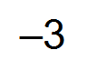 ✓

(ii) 62) = 4 ✓✓

(iii) 5 units2 ✓✓

(b) 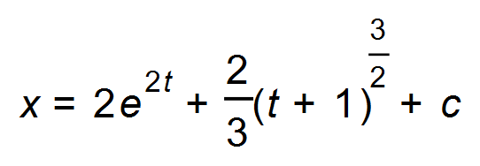 ✓

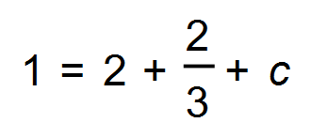 ✓

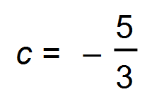

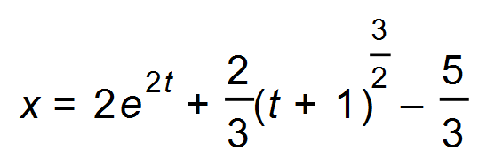 ✓ [8]

8. (a) 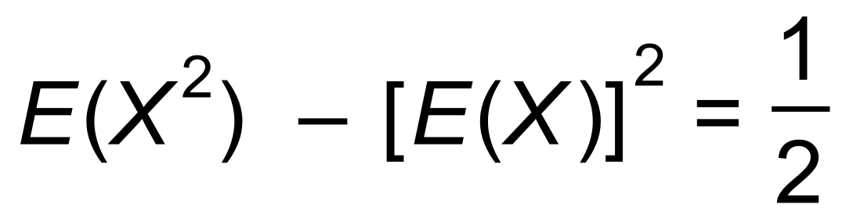

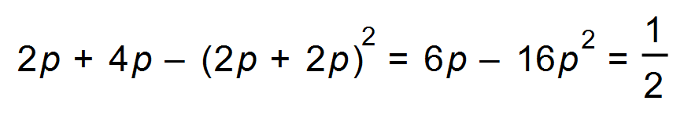 ✓

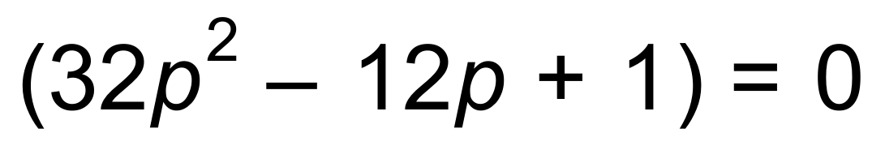

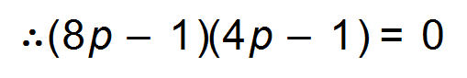

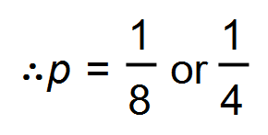 ✓

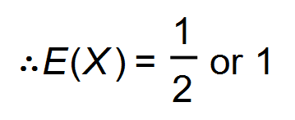 ✓✓

(b) (i) 21 ✓

(ii) Standard deviation of *X* = 3

|2| x 3 = 6 ✓✓ [7]

9. (a) 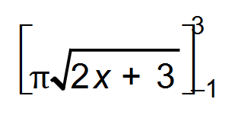 ✓

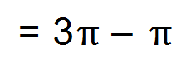 = 2π✓

(b) 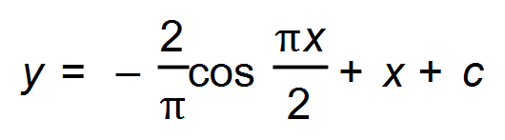 ✓

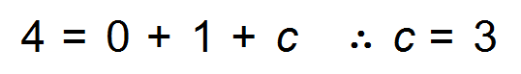 ✓

Its path is 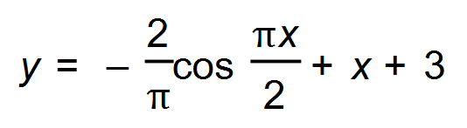 ✓ [5]

***Calculator−assumed Solutions***

10. (a) 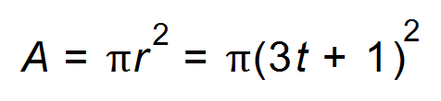 ✓

(b) 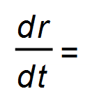3 cm/s ✓

(c) 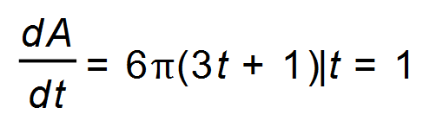

=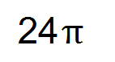 cm2/s ✓

(d) 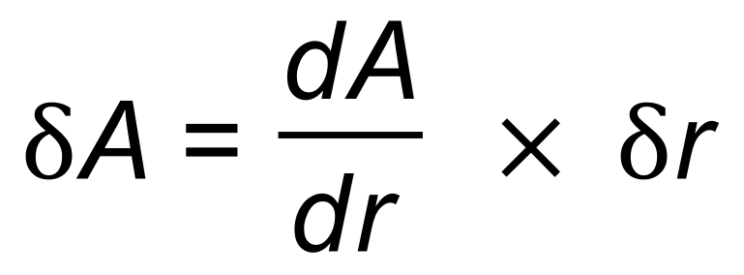

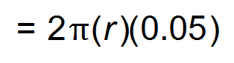 ✓✓

When *r =* 4 , =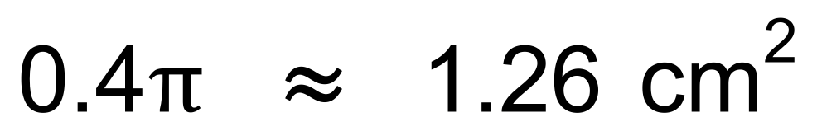 ✓ [6]

11. (a) Let P(*X* = 0) = *k* then 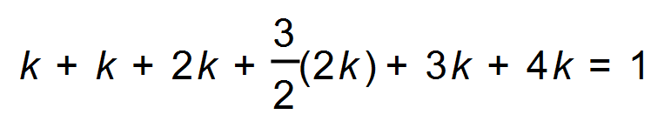

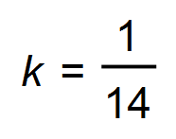 ✓

|  |  |  |  |  |  |  |
| --- | --- | --- | --- | --- | --- | --- |
| *X* | 0 | 1 | 2 | 3 | 4 | 5 |
| P(*X* = *x*) |  |  |  |  |  |  |
| Frequency | 23 | 23 | 46 | 69 | 69 | 92 |

✓✓✓

(b) mode = 5 ✓

mean = 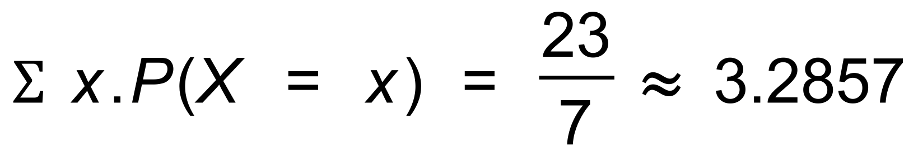 ✓

(c) 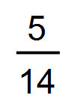 ✓ [7]

12. (a)

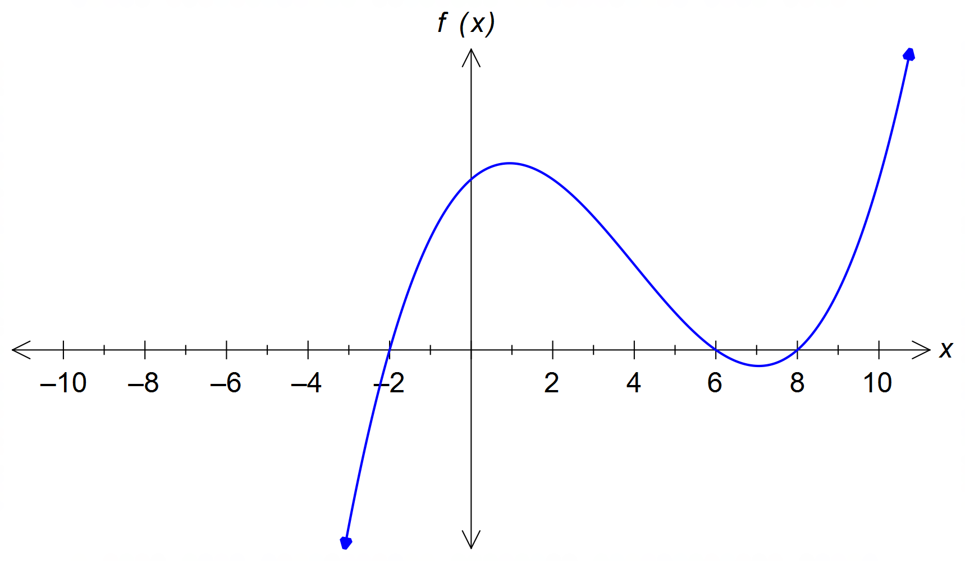

✓✓✓

(b)

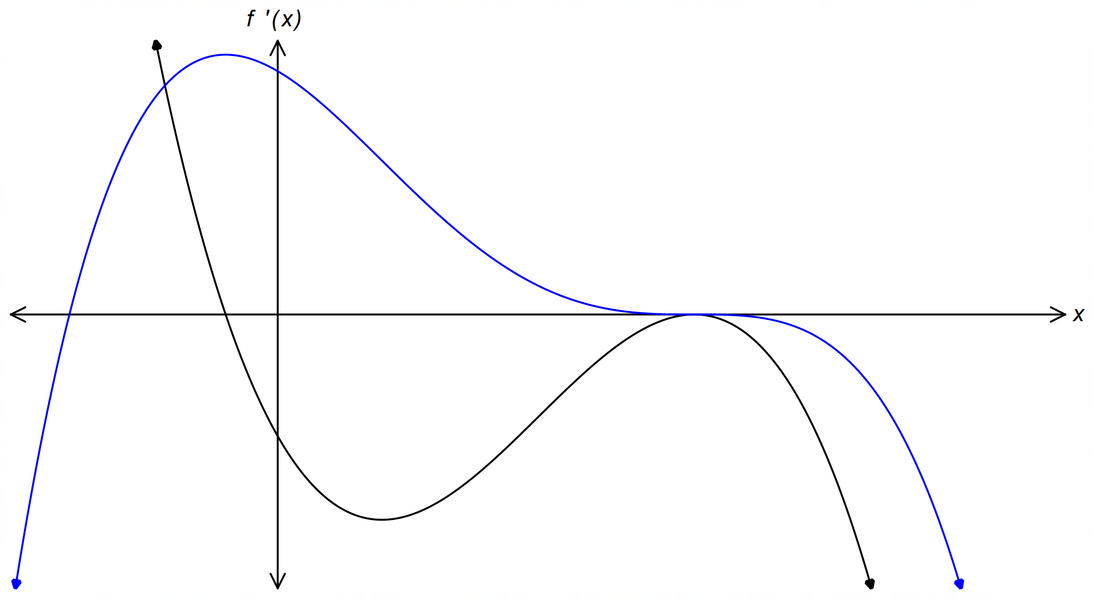

✓✓

(c) 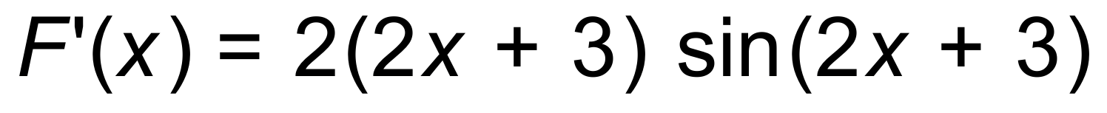 ✓ [6]

13. (a) 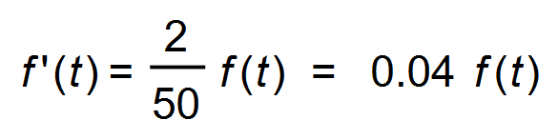

 *k* = 0.04 ✓

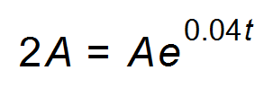 ✓

*t* = 17.3 days ✓

(b) (i) 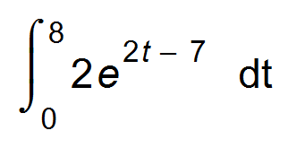= 8103.083 m2 ✓

(ii) 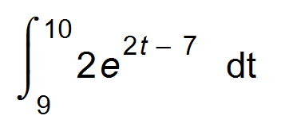 = 382 539.25 m2  ✓

(iii) The exponential growth of the area becomes too large

too quickly for the model to be realistic. ✓ [6]

14. (a) 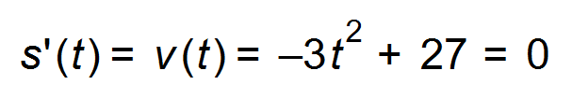 ✓

∴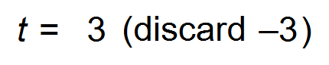 ✓

The maximum distance from O occurs at *t* = 3 seconds and

then the particle turns back towards O.

(b) 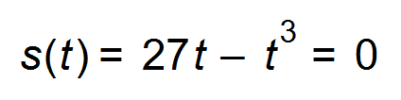

∴ 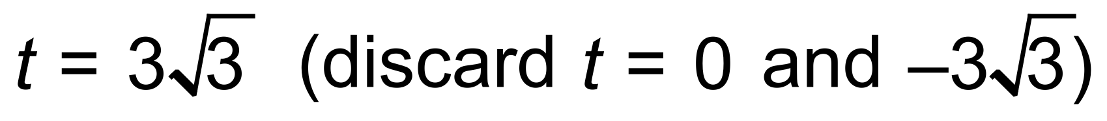 ✓

∴ 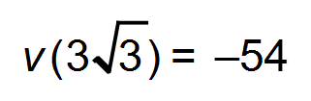 ✓

Therefore speed when the particle returns to O is 54 cm/s. ✓ [5]

15. 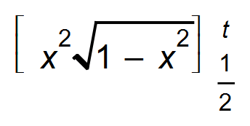 = 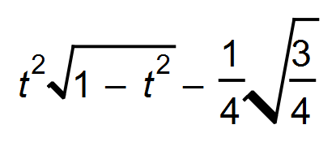 ✓✓

A(*t*)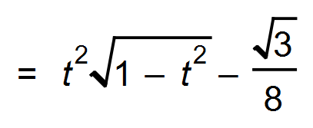 ✓ [3]

16. (a) Profit = Revenue Cost

 ✓

 ✓

(b) 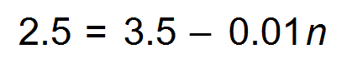 ✓

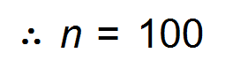 He will sell 100 figs ✓

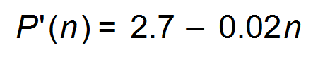 where *n* =100 ✓

The marginal profit is 0.7 = 70 cents ✓ [6]

17. (a) (i)

|  |  |  |  |  |
| --- | --- | --- | --- | --- |
| Y | 0 | 1 | 2 | 3 |
| P(Y= *y*) |  |  |  |  |

✓✓

(ii) E(*Y*) = 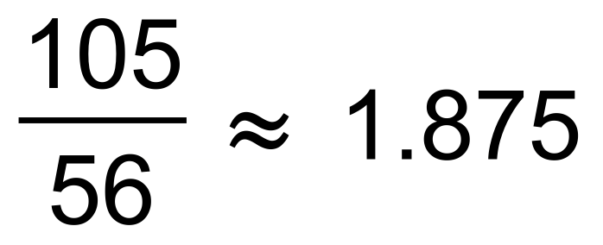 ✓

Var(*Y*) = 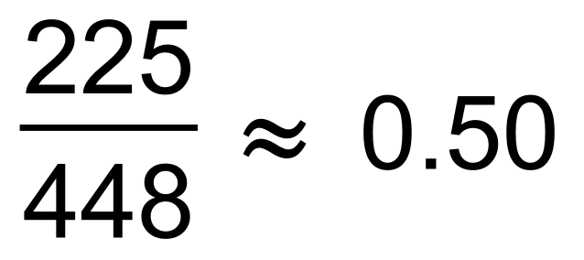 ✓

(iii) 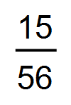 ✓

(b) (i) 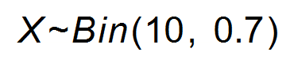

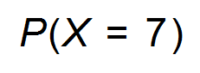= 0.2668 ✓

(ii) 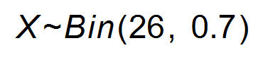

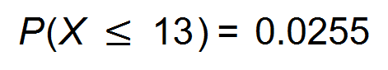 ✓

(c) 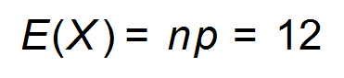 ✓

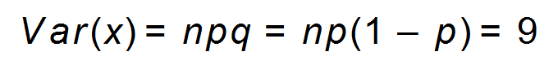 ✓

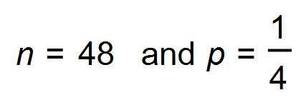 ✓ [10]

18. (a) The amount of water cannot be a negative amount.

If no water flows in or out the functions can equal zero. ✓✓

(b) 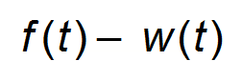 megalitres ✓

(c) 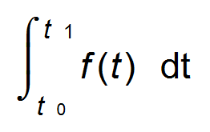 ✓

(d) 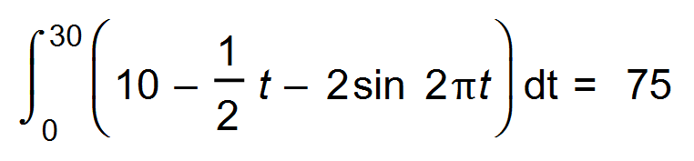 ✓

75 megalitres of water. ✓

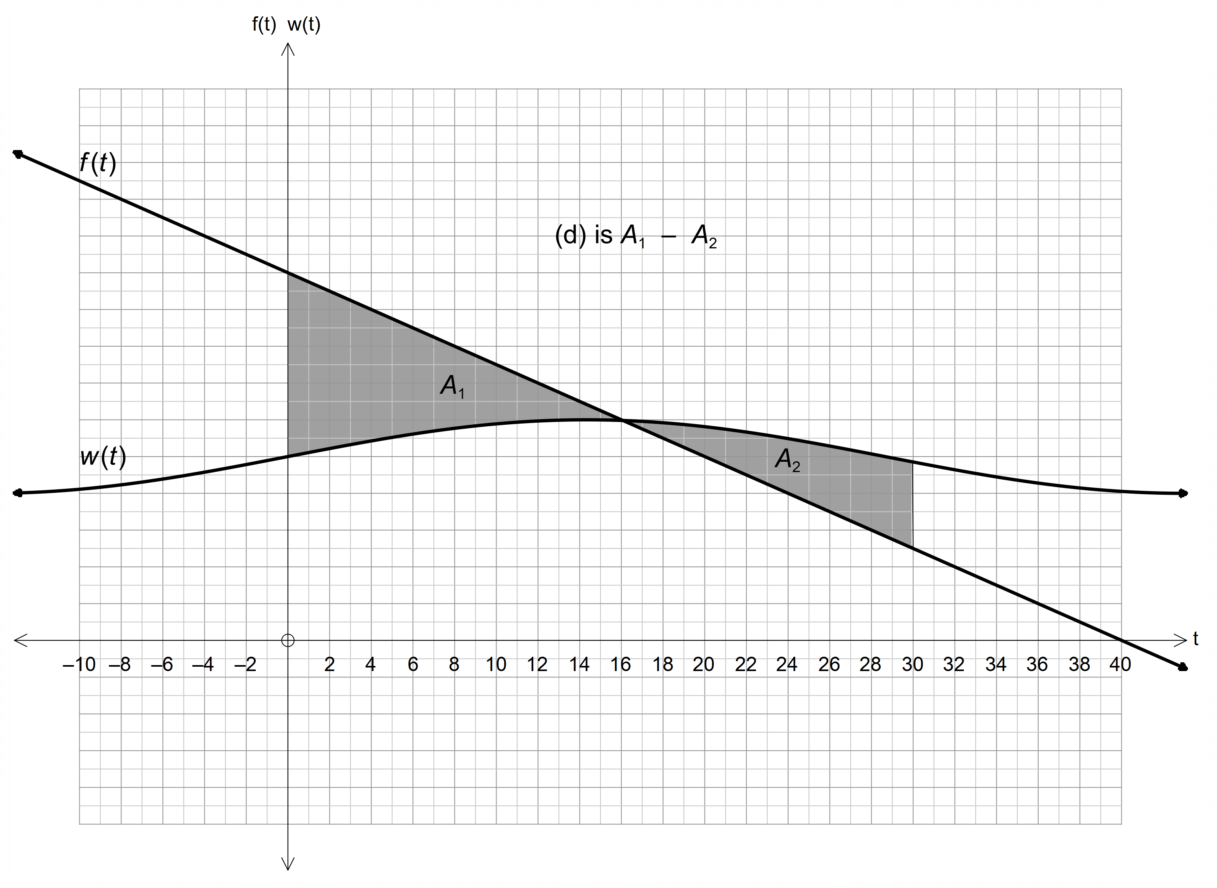

(e)

✓✓ [8]

19. (a) (i) Each washing machine is an independent trial. ✓

There are two outcomes: Success (a washing machine works)

and Failure (a washing machine is broken.) ✓

(ii) E(*X*) = *p* = 0.2 ✓

Var (*X*) = *p*(1 *p*) = 0.2 x 0.8 = 0.16

Standard deviation = 0.4 ✓

(b) (i) This means that the first mobile phone was selected and found to be defective. (0 non-defective mobile phones were found) ✓

P(*X* = 0) = 0.03 ✓

(ii) This means that the first two mobile phones selected

were found to be non-defective but the third mobile phone

selected was defective. ✓

P(*X* = 2) = 0.97 x 0.97 x 0.03 = 0.028227 ✓

(iii) 0.975 x 0.03 = 0.02576 ✓✓

(iv) 1 − [P(0) + P(1) + P(2)] = 0.91267 ✓✓ [12]

20. (a) 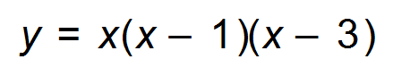

Graph cuts the *x-* axis at 0, 1 and 3. ✓

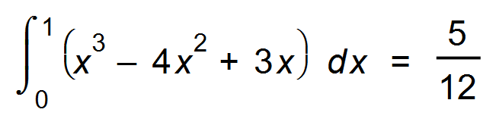 ✓

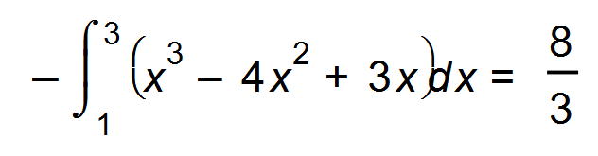 ✓

Area = 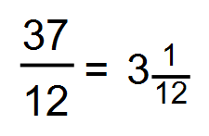

(b) 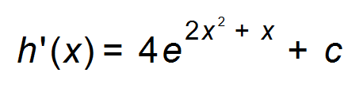 ✓

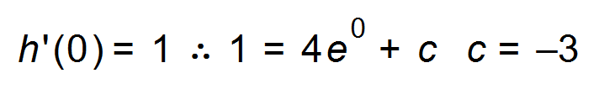 ✓

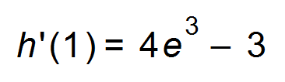 which is the gradient at *x* = 1 ✓

(c) Graphs intersect at *x* = 0.6349, 2.5067 ✓



= 2.5203 units2 ✓✓ [9]

Or: 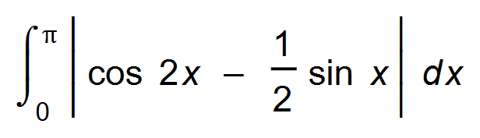= 2.5203 units2

21. In triangle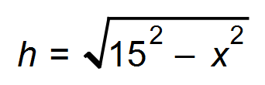 therefore A=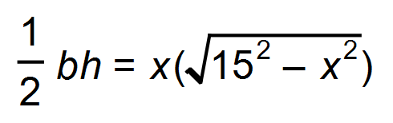 ✓

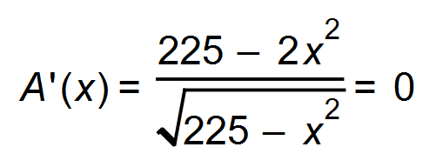 ✓

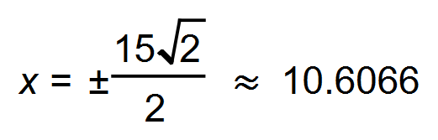 (Discard negative value for *x.*) ✓

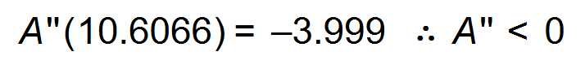 therefore maximum ✓

Maximum area is 112.5 cm2  ✓ [5]

22. (a) 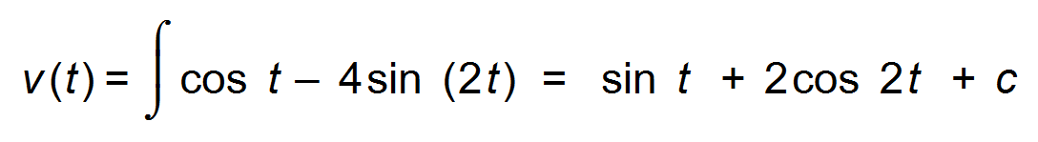 ✓

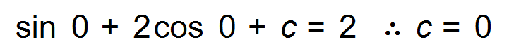

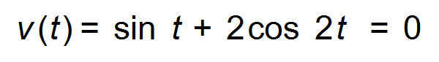 ✓

The particle changes direction when *t =* 1.003 s or *t* = 2.139 s ✓

(b) 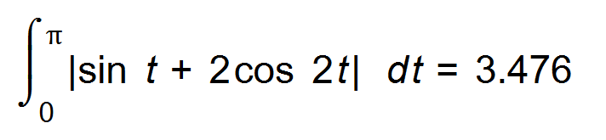m2 ✓✓ [5]

23. (a)

|  |  |  |  |  |  |
| --- | --- | --- | --- | --- | --- |
| *g*(0) | *g*(0.2) | *g*(0.4) | *g*(0.6) | *g*(0.8) | *g*(1) |
| 1 | 0.96 | 0.85 | 0.70 | 0.53 | 0.37 |

✓

Area from left = 0.2 (1 + 0.96 + 0.85 + 0.70 + 0.53) = 0.808 ✓

Area from right = 0.2 (0.96 + 0.85 + 0.70 + 0.53 + 0.37) = 0.682 ✓

Average = 0.745 = 0.75 units2 ✓

(b) As the width of the rectangle tends to 0,

the more accurate will be the area. ✓ [5]

24. (a) *t* = 110 years

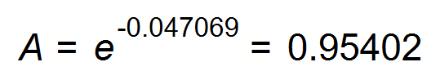grams ✓

Therefore 4.598 % has decayed. ✓

(b) 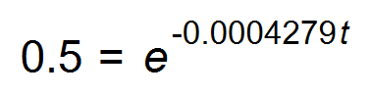 ✓

*t* = 1619.88 1620 years ✓

(c) 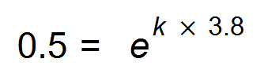

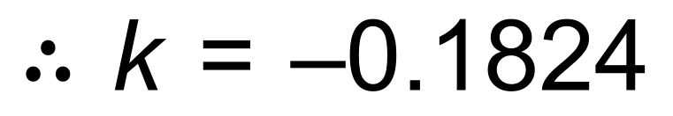 ✓

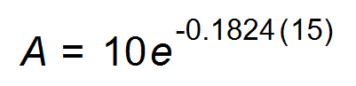 ✓

0.648 mg of radon remains ✓ [7]

**END OF QUESTIONS**